**PRESS RELEASE**

**Lisbon hosts the Carlsberg Football Park, featuring the broadcast of the UEFA NATIONS LEAGUE 2025**

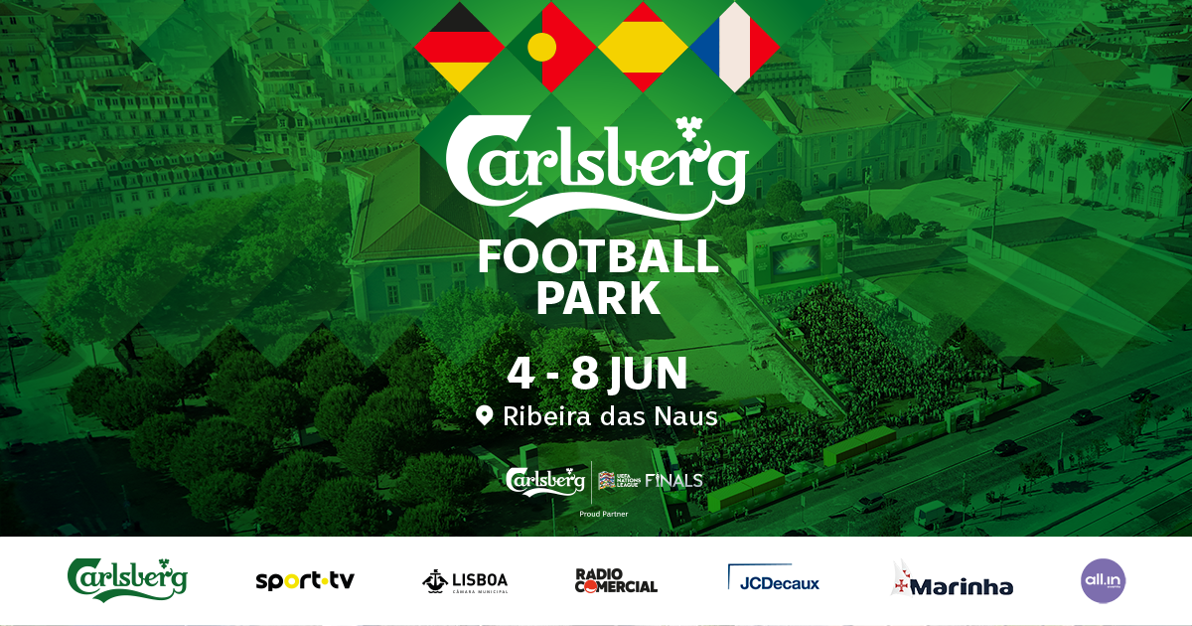

* From June 4th to 8th, at Ribeira das Naus
* Free entry, limited to venue capacity
* Space dedicated to the broadcast of the UEFA Nations League 2025

Carlsberg joins Sport TV, Câmara Municipal de Lisboa, and All In Events to announce the creation of the Carlsberg Football Park. The official Lisbon venue for broadcasting the UEFA Nations League semi-finals and finals will be in the gardens of Ribeira das Naus. Rádio Comercial, JC Decaux, and the Portuguese Navy also join this major football celebration.

With official authorization from UEFA and free entry, the Carlsberg Football Park promises to be the favorite meeting point for everyone wishing to watch the matches of the European competition. Featuring a giant screen and a festive atmosphere, the space will provide live broadcasts of the games and will also include food areas, live entertainment, and interactive activities for all.

**Statement from Bruno Albuquerque, Marketing Director for Beers and Sponsorships at Super Bock Group:**

“With the Carlsberg Football Park, we want to go beyond simply broadcasting a football match. We aim to create a true collective moment of celebration, where football is experienced with intensity, emotion, and sharing. This initiative puts the fans at the center of everything and reinforces our ambition to promote meaningful experiences that connect people and inspire a balanced lifestyle.”

**Statement from Nuno Ferreira Pires, CEO of SPORT TV in Portugal:**

“The strength of football comes from the fans. Fans are responsible for creating the unique and electrifying atmosphere experienced in stadiums, which drives players, clubs, and national teams. That is why SPORT TV is extremely proud to partner with Carlsberg Football Park, committing to bring all the emotions of our National Team’s achievements to the Portuguese people, now in the final phase of the Nations League.”

**Statement from Rui Cordeiro, Lisbon City Council Sports Councillor:**

“Lisbon is a stage for great emotions and celebrations, and the Carlsberg Football Park represents exactly that: a city that lives sport, welcoming with enthusiasm those who live here and those who visit us. This initiative reinforces our commitment to sport for all, in an iconic public space that combines football, culture, and outdoor socializing. We are ready to cheer for our national team, with open arms for another great celebration in Lisbon.”

**Statement from Francisco Mello e Castro, CEO of All In Events:**

“More than just broadcasting the final games of the UEFA Nations League, we want the Carlsberg Football Park to be the main meeting point for everyone who wants to enjoy good weather and this European competition with lots of celebration and fun after work and during the weekend. That’s why choosing such a central and pleasant location as the gardens of Ribeira das Naus is so important, a result of the partnership we established with Câmara Municipal de Lisboa and the Portuguese Navy — as well as Carlsberg, which allows us all to toast to summer and, ideally, to our national team bringing the trophy home!”

The Carlsberg Football Park kicks off on June 4th with the Portugal vs. Germany match. Doors and all activities will open at 4 pm with a special broadcast of Rádio Comercial’s program “Já se Faz Tarde,” and the giant screen broadcast of the game will start at 8 pm. Fans will also enjoy a lively DJ set before, during, and after the match.

The space will be open from June 4th to 8th, from 4 pm to 11 pm (June 4th), from 6 pm to 11 pm (June 5th), from 6 pm to midnight (June 6th and 7th), and from noon to 11 pm (June 8th).

------------------------------------------------------------------------------------------------------------------------------

More informations: <https://www.carlsberg.com/pt-pt/> or <https://www.instagram.com/carlsbergportugal/>

Lisbon, May 27th 2025

Additional information: CATARINA SIMÕES FARINHA :: ISABEL CARRIÇO



Tel. 218 508 110 :: Tlm. 932 260 035 :: 965 232 496

CATARINAFARINHA[@LPMCOM.PT](mailto:RAQUELPELICA@LPMCOM.PT) :: [ISABELCARRICO@LPMCOM.PT](mailto:ISABELCARRICO@LPMCOM.PT)

Ed. Lisboa Oriente, Av. Infante D. Henrique, 333 H, esc.49, 1800-282 Lisboa

